深入Servlet技术
2017/1/22

HTTP简介

一）HTTP默认端口：80

HTTP头数据
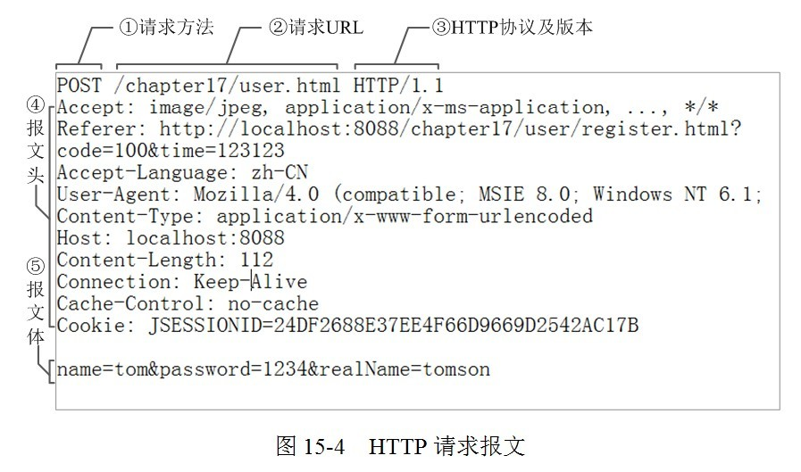

- 请求报文
- Accpt: 告诉服务器端客户端可以接受的响应类型。
- Referer: 表示请求时从哪个URL过来的
- Cookie: 传给服务端的Cookie
- Cache-Control: 对服务器端返回的响应的缓存进行控制

- 响应报文
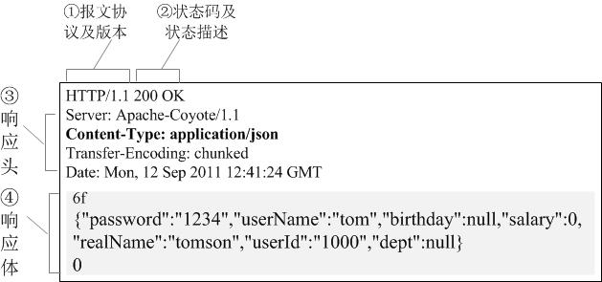

- 响应状态码：
1xx 消息，一般是告诉客户端，请求已经收到了，正在处理，别急...
2xx 处理成功，一般表示：请求收悉、我明白你要的、请求已受理、已经处理完成等信息.
3xx 重定向到其它地方。它让客户端再发起一个请求以完成整个处理。
4xx 处理发生错误，责任在客户端，如客户端的请求一个不存在的资源，客户端未被授权，禁止访问等。
5xx 处理发生错误，责任在服务端，如服务端抛出异常，路由出错，HTTP版本不支持等。

2）
Cache-Control
响应输出到客户端后，服务端通过该报文头属告诉客户端如何控制响应内容的缓存。
下面，的设置让客户端对响应内容缓存3600秒，也即在3600秒内，如果客户再次访问该资源，直接从客户端的缓存中返回内容给客户，不要再从服务端获取 （当然，这个功能是靠客户端实现的，服务端只是通过这个属性提示客户端“应该这么做”，做不做，还是决定于客户端，如果是自己宣称支持HTTP的客户端，则就应该这样实现） 。
Java代码
- Cache-Control: max-age=3600
ETag
一个代表响应服务端资源（如页面）版本的报文头属性，如果某个服务端资源发生变化了，这个ETag就会相应发生变化。它是Cache-Control的有益补充，可以让客户端“更智能”地处理什么时候要从服务端取资源，什么时候可以直接从缓存中返回响应。
关于ETag的说明，你可以参见： http://en.wikipedia.org/wiki/HTTP_ETag 。
Spring 3.0还专门为此提供了一个org.springframework.web.filter.ShallowEtagHeaderFilter（实现原理很简单，对JSP输出的内容MD5，这样内容有变化ETag就相应变化了），用于生成响应的ETag，因为这东东确实可以帮助减少请求和响应的交互。
下面是一个ETag：
Java代码
- ETag: "737060cd8c284d8af7ad3082f209582d"
Location
我们在JSP中让页面Redirect到一个某个A页面中，其实是让客户端再发一个请求到A页面，这个需要Redirect到的A页面的URL，其实就是通过响应报文头的Location属性告知客户端的，如下的报文头属性，将使客户端redirect到iteye的首页中：
Java代码
- Location: http://www.iteye.com
Set-Cookie
服务端可以设置客户端的Cookie，其原理就是通过这个响应报文头属性实现的：
Java代码
- Set-Cookie: UserID=JohnDoe; Max-Age=3600; Version=1
其它HTTP响应报文头属性
更多其它的HTTP响应头报文，参见： http://en.wikipedia.org/wiki/List_of_HTTP_header_fields

3）
在服务端可以通过HttpServletResponse的API写响应报文头的属性：
Java代码
- //添加一个响应报文头属性
- void setHeader(String name, String value)
象Cookie，Location这些响应都是有福之人，HttpServletResponse为它们都提供了VIP版的API：
Java代码
- //添加Cookie报文头属性
- void addCookie(Cookie cookie)

- //不但会设置Location的响应报文头，还会生成303的状态码呢，两者天仙配呢
- void sendRedirect(String location)

二、Servlet概述

浏览器提交的请求时遵循HTTP协议的文本。这段文本被Tomcat服务器接收并解析，封装成HttpServletRequest类的request对象。
Tomcat同时把输出流封装为HttpServletRespone类型的respone对象。

Java web目录结构
文件夹 | 描述
/ | Web应用根目录
/WEB-INF | 受保护，无法通过浏览器直接访问，但可通过代码访问
/WEB-INF/web.xml | Web主配置文件
/WEB-INF/classes/ | class类文件夹
/WEB-INF/lib | 放jar包

编写Servlet

编写实现过程略。
用web.xml配置Servlet细节：
- <servlet-name>可以是任意字符串，但必须保证唯一性。
- 配置参数：
<init-param>
<param-name>message</param-name>
<param-value>welcome to FirstServlet</param-value>
</init-param>
- <load-on-startup>1</load-on-startup>配置为1，服务器启动时加载Servlet，配置为0在第一次请求Servlet时才加载。

<servlet-mapping>
<servlet-name>RequestServlet</servlet-name>
<url-pattern>/servlet/RequestServlet</url-pattern>
<servlet-mapping>
<url-pattern>的值前面加上Web应用程序的路径，在加上服务器域名和端口号信息就是访问该Servlet的网址。如：http://localhost:8080/servlet/servlet/RequestServlet。
<url-pattern>中的通配符。
- *：代表任意字符。
Java EE5开始同一个<servlet-mapping>可以配置多个<url-pattern>

- 如下：
<init-param>中的参数只能由特定的servlet来获取，如果要所有的servlet都能获取，必须使用上下文参数:
<context-param>
<param-name>startPoint</param-name>
<param-value>2000</param-value>
</context-param>

本节API
1.javax.servlet.http.HttpServlet
1)p
执行 doGet 前会先执行 getLastModified，如果浏览器发现 getLastModified 返回的数值与上次访问时返回的数值相同，则认为该文档没有更新，浏览器采用缓存而不执行 doGet。如果 getLastModified 返回 -1，则认为是时刻更新的，总是执行该函数。-1 则认为是实时更新。默认为 -1。

- public ServletContext getServletContext()
Returns a reference to the {@link ServletContext} in which the caller
is executing.

- javax.servlet.http.HttpServletRequest
- Public void setCharacterEncoding()
void setCharacterEncoding(String env)
throws UnsupportedEncodingException
Overrides the name of the character encoding used in the body of this request. This method must be called prior to reading request parameters or reading input using getReader(). Otherwise, it has no effect.
Parameters:
env - String containing the name of the character encoding.
Throws:
UnsupportedEncodingException - if this ServletRequest is still in a state where a character encoding may be set, but the specified encoding is invalid

- String getRequestURI()
Returns the part of this request's URL from the protocol name up to the query string in the first line of the HTTP request. The web container does not decode this String. For example:
First line of HTTP request | Returned Value
POST /some/path.html HTTP/1.1 |  | /some/path.html
GET http://foo.bar/a.html HTTP/1.0 |  | /a.html
HEAD /xyz?a=b HTTP/1.1 |  | /xyz

3)String getParameter(String name)
Returns the value of a request parameter as a String, or null if the parameter does not exist. Request parameters are extra information sent with the request. For HTTP servlets, parameters are contained in the query string or posted form data.
You should only use this method when you are sure the parameter has only one value. If the parameter might have more than one value, use getParameterValues(java.lang.String).
If you use this method with a multivalued parameter, the value returned is equal to the first value in the array returned by getParameterValues.
If the parameter data was sent in the request body, such as occurs with an HTTP POST request, then reading the body directly via getInputStream() or getReader() can interfere with the execution of this method.
Parameters:
name - a String specifying the name of the parameter
Returns:
a String representing the single value of the parameter
See Also:
getParameterValues(java.lang.String)

- String getMethod()
POST?/GET?

5)String getAuthType()

6)java.lang.String getLocalAddr()
返回服务器IP

- `java.util.Locale getLocale()

8)java.lang.String getContextPath()
Returns the portion of the request URI that indicates the context of the request. The context path always comes first in a request URI. The path starts with a "/" character but does not end with a "/" character. For servlets in the default (root) context, this method returns "". The container does not decode this string.
It is possible that a servlet container may match a context by more than one context path. In such cases this method will return the actual context path used by the request and it may differ from the path returned by the ServletContext.getContextPath() method. The context path returned by ServletContext.getContextPath() should be considered as the prime or preferred context path of the application.
Returns:
a String specifying the portion of the request URI that indicates the context of the request
See Also:
ServletContext.getContextPath()
request.getContextPath()是在开发Web项目时，经常用到的方法，其作用是获取当前的系统路径。
当使用Tomcat作为Web服务器，项目一般部署在Tomcat下的webapps的目录下。具体来说主要用两种部署的路径：
一是将web项目中的webRoot下的文件直接拷贝到webapps/ROOT下（删除ROOT下的原有文件）；
另一中方法在Tomcat下的webapps中创建以项目名称命名（当然也可以用其他的名称）的文件夹，并将webRoot下的文件直接拷贝到该文件夹下。
对于第一部署方法，request.getContextPath()的返回值为空（即："",中间无空格，注意区分null)。
对于第二部署方法，其返回值为：/创建的文件夹的名称。
9)java.lang.String getQueryString()
返回？后面的字符串

10）java.lang.String getPathInfo()

11）java.lang.String getHeader(java.lang.String name)

12）RequestDispatcher getRequestDispatcher(java.lang.String path)
Returns a RequestDispatcher object that acts as a wrapper for the resource located at the given path. A RequestDispatcher object can be used to forward a request to the resource or to include the resource in a response. The resource can be dynamic or static.
The pathname specified may be relative, although it cannot extend outside the current servlet context. If the path begins with a "/" it is interpreted as relative to the current context root. This method returns null if the servlet container cannot return a RequestDispatcher.
The difference between this method and ServletContext#getRequestDispatcher is that this method can take a relative path.
Parameters:
path - a String specifying the pathname to the resource. If it is relative, it must be relative against the current servlet.
Returns:
a RequestDispatcher object that acts as a wrapper for the resource at the specified path, or null if the servlet container cannot return a RequestDispatcher
See Also:
RequestDispatcher, ServletContext#getRequestDispatcher
方法参数必修以“/”开始，“/”表示web程序根目录，如，要跳转到http://localhost:8080/servlet/servlet/AServlet.参数为/servlet/AServlet

3.javax.servlet.http.HttpServletResponse
1)Public void setCharacterEncoding("UTF-8")
setCharacterEncoding
void setCharacterEncoding(String charset)
Sets the character encoding (MIME charset) of the response being sent to the client, for example, to UTF-8. If the character encoding has already been set by setContentType(java.lang.String) or setLocale(java.util.Locale), this method overrides it. Calling setContentType(java.lang.String) with the String of text/html and calling this method with the String of UTF-8 is equivalent with calling setContentType with the String of text/html; charset=UTF-8.
This method can be called repeatedly to change the character encoding. This method has no effect if it is called after getWriter has been called or after the response has been committed.
Containers must communicate the character encoding used for the servlet response's writer to the client if the protocol provides a way for doing so. In the case of HTTP, the character encoding is communicated as part of the Content-Type header for text media types. Note that the character encoding cannot be communicated via HTTP headers if the servlet does not specify a content type; however, it is still used to encode text written via the servlet response's writer.
Parameters:
charset - a String specifying only the character set defined by IANA Character Sets (http://www.iana.org/assignments/character-sets)
Since:
2.4
See Also:
#setLocale

2)void setContentType(java.lang.String type)
Sets the content type of the response being sent to the client, if the response has not been committed yet. The given content type may include a character encoding specification, for example, text/html;charset=UTF-8. The response's character encoding is only set from the given content type if this method is called before getWriter is called.
This method may be called repeatedly to change content type and character encoding. This method has no effect if called after the response has been committed. It does not set the response's character encoding if it is called after getWriter has been called or after the response has been committed.
Containers must communicate the content type and the character encoding used for the servlet response's writer to the client if the protocol provides a way for doing so. In the case of HTTP, the Content-Type header is used.
Parameters:
type - a String specifying the MIME type of the content
See Also:
setLocale(java.util.Locale), setCharacterEncoding(java.lang.String), getOutputStream(), getWriter()

3)java.io.PrintWriter getWriter() throws java.io.IOException
Returns a PrintWriter object that can send character text to the client. The PrintWriter uses the character encoding returned by getCharacterEncoding(). If the response's character encoding has not been specified as described in getCharacterEncoding (i.e., the method just returns the default value ISO-8859-1), getWriter updates it to ISO-8859-1.
Calling flush() on the PrintWriter commits the response.
Either this method or getOutputStream() may be called to write the body, not both.
Returns:
a PrintWriter object that can return character data to the client
Throws:
UnsupportedEncodingException - if the character encoding returned by getCharacterEncoding cannot be used
IllegalStateException - if the getOutputStream method has already been called for this response object
java.io.IOException - if an input or output exception occurred
See Also:
getOutputStream(), setCharacterEncoding(java.lang.String)
4)void sendRedirect(java.lang.String location) throws java.io.IOException
Sends a temporary redirect response to the client using the specified redirect location URL and clears the buffer. The buffer will be replaced with the data set by this method. Calling this method sets the status code to SC_FOUND 302 (Found). This method can accept relative URLs;the servlet container must convert the relative URL to an absolute URL before sending the response to the client. If the location is relative without a leading '/' the container interprets it as relative to the current request URI. If the location is relative with a leading '/' the container interprets it as relative to the servlet container root.
If the response has already been committed, this method throws an IllegalStateException. After using this method, the response should be considered to be committed and should not be written to.
Parameters:
location - the redirect location URL
Throws:
java.io.IOException - If an input or output exception occurs
IllegalStateException - If the response was committed or if a partial URL is given and cannot be converted into a valid URL。
重定向是利用服务器返回的状态码来实现的，301表示永久重定向，302表示临时重定向。

4.javax.servlet.ServletConfig

1.ServletContext getServletContext()
Returns a reference to the ServletContext in which the caller is executing.
Returns:
a ServletContext object, used by the caller to interact with its servlet container

四、资源注射

@Resource
Java5.0新特性，通过注解完成。Tomcat启动时会把web.xml里配置信息主动“注射”到Servlet中。如：
Servlet中：
@Resource(name="message")
private String message;

private @Resource(name="hello") String hello;
private @Resource(name="i") int i;

web.xml：中
<env-entry>
<env-entry-name>hello</env-entry-name>
<env-entry-type>java.lang.String</env-entry-type>
<env-entry-value>
Hello, Welcome to the JavaEE Resource Injection.
</env-entry-value>
</env-entry>

<env-entry>
<env-entry-name>i</env-entry-name>
<env-entry-type>java.lang.Integer</env-entry-type>
<env-entry-value>30</env-entry-value>
</env-entry>

提交表单信息

一）概述
HTML中使用FROM提交数据。当FROM的method属性设置为GET时浏览器就以GET方式提交。Action属性设置数据提交到哪个URL。
以GET方式提交数据时，浏览器把表单内容组成一个查询字符串，（Query String），各个变量之间用&链接，然后以Servlet路径加问号“？”加查询字符串的形式获取服务器内容。如：http://servername/someServlet?a=aValue&b=bValue

上传文件
- 客户端
- from的enctype属性要设置为multipart/form-data method为post
- 使用文件域<input type=”file”/>

- 服务器端
实例代码；
package me.gacl.web.controller;

import java.io.File;
import java.io.FileOutputStream;
import java.io.IOException;
import java.io.InputStream;
import java.util.List;
import java.util.UUID;

import javax.servlet.ServletException;
import javax.servlet.http.HttpServlet;
import javax.servlet.http.HttpServletRequest;
import javax.servlet.http.HttpServletResponse;
import org.apache.commons.fileupload.FileItem;
import org.apache.commons.fileupload.FileUploadBase;
import org.apache.commons.fileupload.ProgressListener;
import org.apache.commons.fileupload.disk.DiskFileItemFactory;
import org.apache.commons.fileupload.servlet.ServletFileUpload;

/**
* @ClassName: UploadHandleServlet
* @Description: TODO(这里用一句话描述这个类的作用)
* @author: 孤傲苍狼
* @date: 2015-1-3 下午11:35:50
*
*/
public class UploadHandleServlet extends HttpServlet {

public void doGet(HttpServletRequest request, HttpServletResponse response)
throws ServletException, IOException {
//得到上传文件的保存目录，将上传的文件存放于WEB-INF目录下，不允许外界直接访问，保证上传文件的安全
String savePath = this.getServletContext().getRealPath("/WEB-INF/upload");
//上传时生成的临时文件保存目录
String tempPath = this.getServletContext().getRealPath("/WEB-INF/temp");
File tmpFile = new File(tempPath);
if (!tmpFile.exists()) {
//创建临时目录
tmpFile.mkdir();
}

//消息提示
String message = "";
try{
//使用Apache文件上传组件处理文件上传步骤：
//1、创建一个DiskFileItemFactory工厂
DiskFileItemFactory factory = new DiskFileItemFactory();
//设置工厂的缓冲区的大小，当上传的文件大小超过缓冲区的大小时，就会生成一个临时文件存放到指定的临时目录当中。
factory.setSizeThreshold(1024*100);//设置缓冲区的大小为100KB，如果不指定，那么缓冲区的大小默认是10KB
//设置上传时生成的临时文件的保存目录
factory.setRepository(tmpFile);
//2、创建一个文件上传解析器
ServletFileUpload upload = new ServletFileUpload(factory);
//监听文件上传进度
upload.setProgressListener(new ProgressListener(){
public void update(long pBytesRead, long pContentLength, int arg2) {
System.out.println("文件大小为：" + pContentLength + ",当前已处理：" + pBytesRead);
/**
* 文件大小为：14608,当前已处理：4096
文件大小为：14608,当前已处理：7367
文件大小为：14608,当前已处理：11419
文件大小为：14608,当前已处理：14608
*/
}
});
//解决上传文件名的中文乱码
upload.setHeaderEncoding("UTF-8");
//3、判断提交上来的数据是否是上传表单的数据
if(!ServletFileUpload.isMultipartContent(request)){
//按照传统方式获取数据
return;
}

//设置上传单个文件的大小的最大值，目前是设置为1024*1024字节，也就是1MB
upload.setFileSizeMax(1024*1024);
//设置上传文件总量的最大值，最大值=同时上传的多个文件的大小的最大值的和，目前设置为10MB
upload.setSizeMax(1024*1024*10);
//4、使用ServletFileUpload解析器解析上传数据，解析结果返回的是一个List<FileItem>集合，每一个FileItem对应一个Form表单的输入项
List<FileItem> list = upload.parseRequest(request);
for(FileItem item : list){
//如果fileitem中封装的是普通输入项的数据
if(item.isFormField()){
String name = item.getFieldName();
//解决普通输入项的数据的中文乱码问题
String value = item.getString("UTF-8");
//value = new String(value.getBytes("iso8859-1"),"UTF-8");
System.out.println(name + "=" + value);
}else{//如果fileitem中封装的是上传文件
//得到上传的文件名称，
String filename = item.getName();
System.out.println(filename);
if(filename==null || filename.trim().equals("")){
continue;
}
//注意：不同的浏览器提交的文件名是不一样的，有些浏览器提交上来的文件名是带有路径的，如： c:\a\b\1.txt，而有些只是单纯的文件名，如：1.txt
//处理获取到的上传文件的文件名的路径部分，只保留文件名部分
filename = filename.substring(filename.lastIndexOf("\\")+1);
//得到上传文件的扩展名
String fileExtName = filename.substring(filename.lastIndexOf(".")+1);
//如果需要限制上传的文件类型，那么可以通过文件的扩展名来判断上传的文件类型是否合法
System.out.println("上传的文件的扩展名是："+fileExtName);
//获取item中的上传文件的输入流
InputStream in = item.getInputStream();
//得到文件保存的名称
String saveFilename = makeFileName(filename);
//得到文件的保存目录
String realSavePath = makePath(saveFilename, savePath);
//创建一个文件输出流
FileOutputStream out = new FileOutputStream(realSavePath + "\\" + saveFilename);
//创建一个缓冲区
byte buffer[] = new byte[1024];
//判断输入流中的数据是否已经读完的标识
int len = 0;
//循环将输入流读入到缓冲区当中，(len=in.read(buffer))>0就表示in里面还有数据
while((len=in.read(buffer))>0){
//使用FileOutputStream输出流将缓冲区的数据写入到指定的目录(savePath + "\\" + filename)当中
out.write(buffer, 0, len);
}
//关闭输入流
in.close();
//关闭输出流
out.close();
//删除处理文件上传时生成的临时文件
//item.delete();
message = "文件上传成功！";
}
}
}catch (FileUploadBase.FileSizeLimitExceededException e) {
e.printStackTrace();
request.setAttribute("message", "单个文件超出最大值！！！");
request.getRequestDispatcher("/message.jsp").forward(request, response);
return;
}catch (FileUploadBase.SizeLimitExceededException e) {
e.printStackTrace();
request.setAttribute("message", "上传文件的总的大小超出限制的最大值！！！");
request.getRequestDispatcher("/message.jsp").forward(request, response);
return;
}catch (Exception e) {
message= "文件上传失败！";
e.printStackTrace();
}
request.setAttribute("message",message);
request.getRequestDispatcher("/message.jsp").forward(request, response);
}

/**
* @Method: makeFileName
* @Description: 生成上传文件的文件名，文件名以：uuid+"_"+文件的原始名称
* @Anthor:孤傲苍狼
* @param filename 文件的原始名称
* @return uuid+"_"+文件的原始名称
*/
private String makeFileName(String filename){ //2.jpg
//为防止文件覆盖的现象发生，要为上传文件产生一个唯一的文件名
return UUID.randomUUID().toString() + "_" + filename;
}

/**
* 为防止一个目录下面出现太多文件，要使用hash算法打散存储
* @Method: makePath
* @Description:
* @Anthor:孤傲苍狼
*
* @param filename 文件名，要根据文件名生成存储目录
* @param savePath 文件存储路径
* @return 新的存储目录
*/
private String makePath(String filename,String savePath){
//得到文件名的hashCode的值，得到的就是filename这个字符串对象在内存中的地址
int hashcode = filename.hashCode();
int dir1 = hashcode&0xf; //0--15
int dir2 = (hashcode&0xf0)>>4; //0-15
//构造新的保存目录
String dir = savePath + "\\" + dir1 + "\\" + dir2; //upload\2\3 upload\3\5
//File既可以代表文件也可以代表目录
File file = new File(dir);
//如果目录不存在
if(!file.exists()){
//创建目录
file.mkdirs();
}
return dir;
}

public void doPost(HttpServletRequest request, HttpServletResponse response)
throws ServletException, IOException {

doGet(request, response);
}
}

Servlet生命周期

一）
Servlet会在服务器启动或者第一次请求Servlet的时候开始生命周期，在服务器结束的时候结束生命周期。无论请求多少次Servlet，最多只有一个Servlet实例。

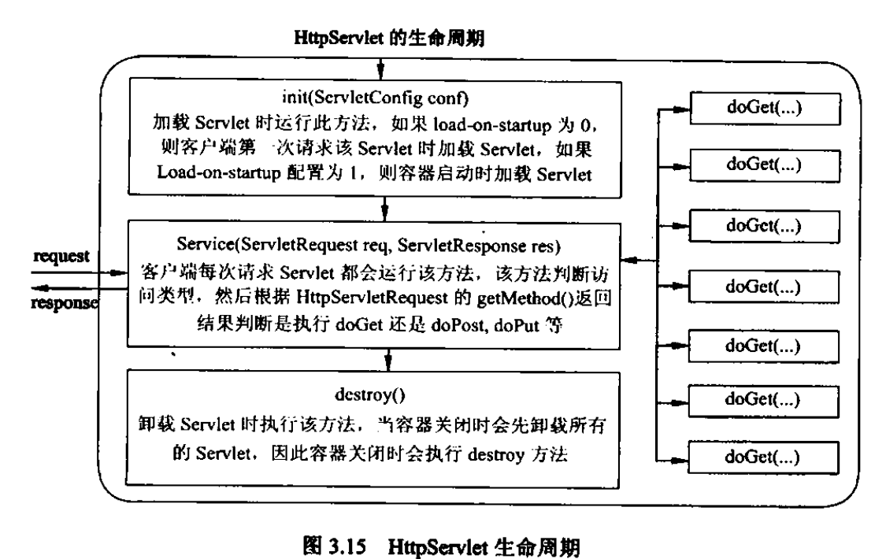

对于init方法，通常我们重写不带参数的init方法。

@PostConstruct与@PreDestroy
这两个注解被用来修饰非静态的void（）方法，且这个方法不能抛出异常声明。
- @PostConstruct:被其注解的方法会在服务器加载Servlet的时候运行，并且此方法会在构造函数之后，init方法之前运行。

2.PreDestroy：被修饰的方法，在destroy方法运行之后，servlet被卸载之前运行。

Servlet的线程安全问题
Servlet是线程不安全的。
